Tab 1

**1. Vision**

To prevent the preventable blindness across India by translating state-of-the-art lab grown research into an AI-powered vision care platform ([www.chaksu.ai](http://www.chaksu.ai)), enabling frontline healthcare workers to deliver last-mile vision care.

**2. Problem**

Effective ophthalmic diagnosis in India, especially in rural areas, faces critical hurdles:

* **Inadequate healthcare infrastructure:**
  + Severe shortage of specialist ophthalmologists in rural regions.
  + Primary Healthcare Centres (PHCs) often lack advanced diagnostic tools for early detection.
* **Limitations of current AI solutions:**
  + Commercial AI tools are often too expensive for widespread adoption.
  + Existing free AI tools lack comprehensive, enterprise-level functionality.
  + Most AI models are not trained on India-specific data, leading to less relevant and inaccurate diagnoses.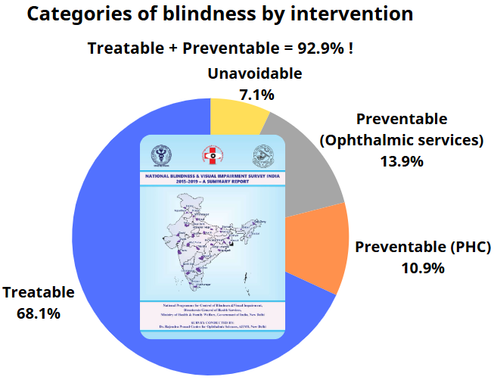
* **Significant consequences:**
  + These issues contribute to a massive socio-economic burden from vision impairment, and cost India an estimated ₹1.158 lakh crore in 2019, representing about 0.57% of India's GDP1.
  + Ironically, 92.9% of blindness in India is either preventable or treatable.

**3. Solution**

ChákṣuAI ([www.chaksu.ai](http://www.chaksu.ai)) is an AI-powered diagnostic platform addressing these challenges:

* **Comprehensive ophthalmic support:**
  + Can diagnose key eye diseases like diabetic retinopathy, glaucoma, and age-related macular degeneration (AMD).
  + Offers disease classification, abnormality detection, retinal segmentation, etc. from fundus images.
  + Includes an integrated, ophthalmology-specific chatbot using a fine-tuned Large Language Model (LLM) with Retrieval Augmented Generation (RAG) to assist frontline healthcare workers in primary screening and referral processes.
* **Advanced and relevant technology:**
  + Utilises cutting-edge AI (Convolutional Neural Networks (CNNs), Transformers, Vision Language Models (VLMs)) for high accuracy.
  + Employs our "Chákṣu" and other India-specific datasets to ensure high demographic relevance and reduced bias.
  + Features visualizations provided by explainable AI for transparency and trust.
* **Accessible and affordable platform:**
  + Aims at a cost-effective model suitable for widespread deployment than the current high-priced solutions.
  + Designed for integration with low-cost smartphone-based fundus imaging attachments, enabling remote deployment.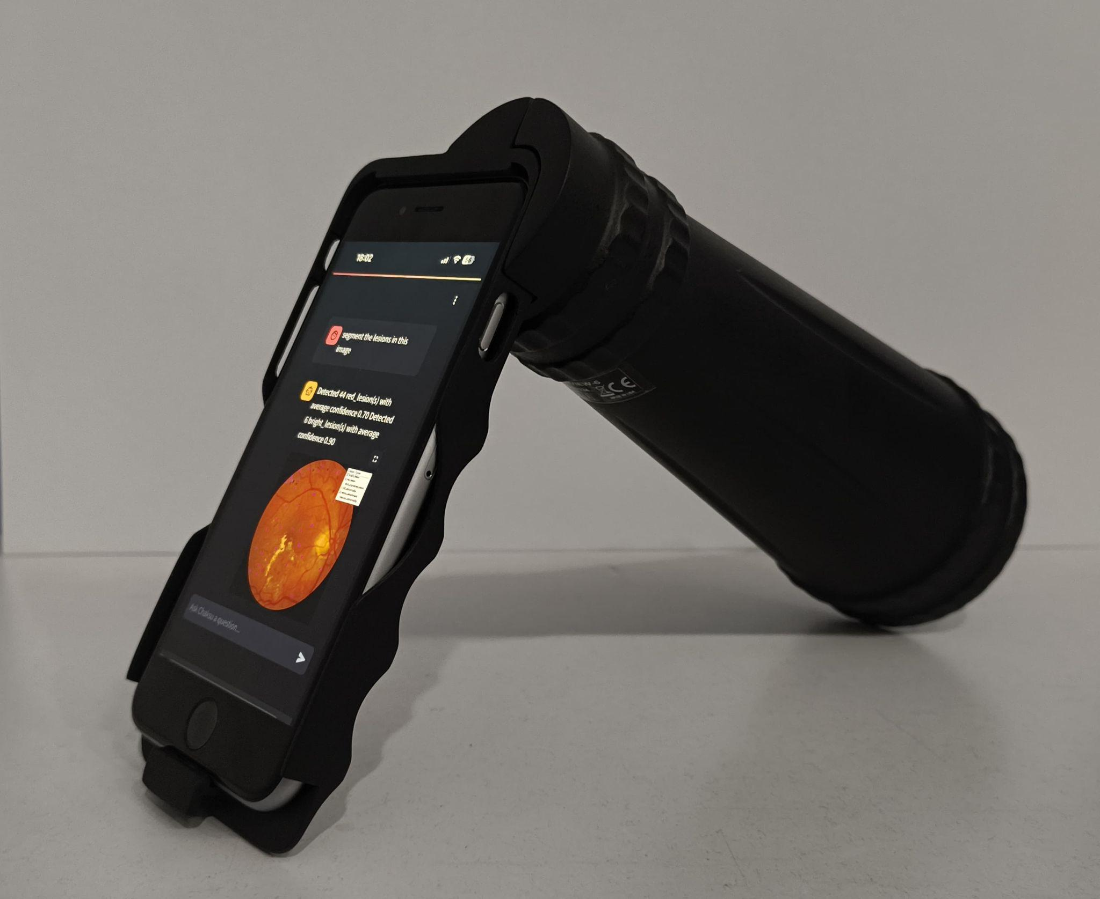

**4. Impact**

Successful deployment and penetration of ChákṣuAI will lead to

* **Democratized access to high-quality diagnostics:**
  + Extend advanced eye care to underserved regions and smaller clinics.
* **Significant reduction in preventable blindness:**
  + Facilitate early diagnosis at scale, tackling 92.9% of avoidable cases.
* **Positive economic and efficiency gains:**
  + Help reduce the national economic burden of visual impairment.
  + Improve diagnostic throughput and healthcare efficiency.

**5. Current Status of Innovation**

We have successfully created functional prototype demonstrations of the ChákṣuAI platform with the objective of obtaining certifications for the diagnostics part from Central Drugs Standard Control Organisation (CDSCO), India. Upon receiving the regulatory approval, pilot screening camps will be conducted at several PHCs.

**6. Competitors & Unique Positioning**

ChákṣuAI competitors can be classified into two categories:

* **High-cost commercial AI solutions:**
  + **Key players:** This segment includes established systems like Zeiss Retina AI, Retmarker, VUNO Med-Fundus AI, Optos AI, IDx-DR, Eyenuk's EyeArt, etc.
  + **Pricing challenge:** A primary barrier to their widespread adoption, especially in resource-constrained settings, is their **very high service costs,** often determined by their high-profit-making strategy. These costs make them largely inaccessible for smaller clinics and rural healthcare centres.
* **Free/Open-source AI tools:**
  + **Key Players:** This includes Google's Automated Retinal Disease Assessment (ARDA), the open-source foundation model RETFound from UCL and Moorfields Eye Hospital, etc.
  + **Functional & Accessibility Trade-off:** While these tools eliminate the high software cost, their accessibility and functionality come with their own set of challenges. Tools such as Google's ARDA, are focused on a single, high-prevalence condition like diabetic retinopathy, and currently lack multi-disease diagnostic capabilities and are only provided through partnerships. Furthermore, open-source models like RETFound are not readily deployable solutions. They require significant technical expertise and computational resources to be adapted and deployed into a clinical workflow.

ChákṣuAI offers a unique value proposition, solving the problems associated with the current solutions:

* **Cost-effective:** Fundamentally designed to be accessible to all, especially underserved communities, breaking down cost barriers.
* **Comprehensive and unified platform:** Integrates multiple diagnostic functionalities – disease classification (diabetic retinopathy, glaucoma, age-related macular degeneration), abnormality detection (microaneurysms, haemorrhages), retinal segmentation (optic disc, optic cup, retinal vessel, lesion), and report generation – into a single platform. It also includes an ophthalmology-specific large language model (LLM) for effective user interaction.
* **India-centric approach:** Our AI models are trained on India-specific datasets (like Chákṣu) to ensure they are relevant for the Indian population.
* **Explainable AI:** Incorporates explainability techniques to provide visual explanations for model predictions, enabling trust and verification by healthcare professionals.
* **Designed for low-resource settings:** Optimized for smartphone-based deployment on the edge, making it suitable for rural PHCs with limited infrastructure.
* **Strong research backing:** Developed within Indian Institute of Science, India’s premier institution, with numerous peer-reviewed publications, ensuring a scientifically sound foundation for the solution.
* **Educational value:** Aims at being a valuable tool for training and skill enhancement for young ophthalmologists and healthcare workers.

**8. Viability & Pricing**

ChákṣuAI 's commercial viability is derived from the following strengths:

* **Addresses a large underserved market:** Targets healthcare providers currently priced out by expensive commercial AI systems.
* **Monetizable competitive edge:** Its India-specific AI development offers superior clinical relevance and accuracy for the Indian population.
* **Scalable model for growth:** The platform is easily scalable, and plans for remote deployment, including integration with an inexpensive smartphone device.
* **Focus on Growth & Reinvestment:** Revenue generated will be reinvested into R&D, dataset expansion, and platform enhancements, ensuring CháksuAI remains a leading, accessible "Make in India, for India" AI solution.

ChákṣuAI will adopt a strategic pricing model designed for market penetration, long-term sustainability, and continuous innovation, aiming to be significantly more cost-effective than current high-cost proprietary AI systems.

* **Tiered Value-Based Offerings:** A two-tiered structure is planned:
  + Essential diagnostic functionalities will be offered at a highly competitive price of **Rs. 20** per scanor special terms for PHCs and research institutions to encourage widespread adoption.
  + Premium/Enterprise tiers will provide comprehensive features, dedicated support, and customization for hospitals and larger clinics.
* **Diverse Revenue Streams:** Sustainability will be achieved through subscriptions for advanced features, fees for support and maintenance, and charges for custom AI solution development or integration.

**9. Details of Funding and Partnerships**

The development of ChákṣuAI has been made possible through the support of several key partnerships spanning funding, data access, and technological collaboration. The research has been generously supported by grants from the IMPacting Research INnovation and Technology (IMPRINT) - India initiative, a national program of the Ministry of Human Resource and Development (MHRD) & Indian Council for Medical Research, Government of India; Science and Engineering Research Board (SERB) - Teachers Associateship for Research Excellence (TARE) Fellowship. Kotak IISc AI-ML Centre (KIAC) at IISc recently funded our ChákṣuAI deep tech initiative, and Zeiss India Pvt. Ltd. has supported “AI for Eye Care” research at our lab by establishing a Centre for Excellence in AI through its CSR initiative.

Chákṣu database creation has been made possible through collaborations with a leading medical institution: Kasturba Medical College, Manipal Academy of Higher Education (MAHE), Manipal, providing a valuable ophthalmological source of data. Early attempts were supported by industry partners – Remidio Innovative Solutions Pvt. Ltd., Forus Health Pvt. Ltd., and Bosch Eye Care Solutions, Bengaluru, India.

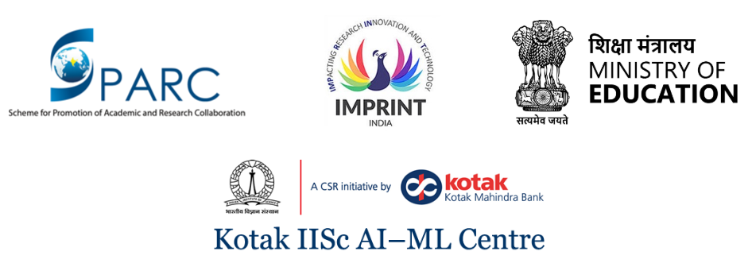

**A Sample ChákṣuAI Retinal Screening Report**

